Wk1 Final Project - Prod. Env.
Note: Before you start work today please take a few minutes to think about your priorities for the week and put them in your 1:1 doc (Remember it is OK if things change, this is not set in stone!)

🔗Objective Review Checklist

Getting Started with your Final Project
- Decide if you want to fork the project template - watch final project set up here
- Deploy your initial project files
- Create a production environment (you will learn more about this in pair programming, but here is a past session to get your started)
- Initialize (declare) the components
- Merged PR with collaboration from your mentor and cohort buddy.
- Make sure you're committing at least 3 times a day and pushing at least 1 time per day (realistically this should be more like 10+).
- Set up connection and test your API & DB, the following will be included in this week’s project milestone submission
  - Document which endpoints you will use - show that each one works
  - Document that you are able to connect to the API using postman and that you understand how to send/receive data from your API
  - Document how you will pass your user data and API data from your backend to your front-end (and vice versa)

Reminder of Requirements
- JavaScript/React
  - RegEx
  - Date/time
  - Objects
  - Arrays
  - Functions
  - Conditionals
  - Iteration using methods and/or loops
  - Data fetch calls with error handling
- CSS (or frameworks)
- Express / Node
- PostgreSQL
- Third-Party API
- Tests for each component (testing functionality and rendering)
- 3 total merged PRs (one each week) with a description
- Each PR should have collaboration from both your mentor and a cohort mate with interactive comments from you resolving any feedback
- Explanation of divergences to requirement

You will be contributing content for a Medium article (see past cohort). Begin working on the following:
- Bio
- Project Name
- Project Description
- API Used
- Hardest Part Of Building Your Project
- Favorite Part Of Building Your Project
🚨 Important things to remember 🚨
You are in charge of your schedule for the next four weeks! Please make sure to really think about how you are prioritizing your time and make sure to rest.
You have some links to past sessions in this doc, this is done on purpose! Watch the videos ahead of your optional pair programming sessions (on 1.5xs if needed - Video Speed Controller) and come prepared with questions to the session. Once your question is answered, feel free to get back into the swing of things hitting your milestone requirements. You could even ask your questions asynchronously over slack, ahead of the session!
I know four weeks sounds like a really long time, but it is not! Time will fly, make sure you are using your time wisely at every step.

What’s Next?
Each day, you will work from your trello board (examples here and here) checking off your various tasks to make progress in your Final Project Plan. You will continue to have pair programming sessions and core skills blocks. In order to keep you on track with meeting project requirements, you will need to submit a document summarizing how you have met this week’s milestones by Friday EOD. During Friday’s wrap up, you will share your project to-date and share how you have hit your milestones.

🚨Reminder🚨
- If you feel like your brain is not working - TAKE A BREAK
- If you feel like you are going in circles - TAKE A BREAK
- If you can’t figure something out after 30 minutes - TAKE A BREAK, ASK FOR HELP
- If you are not clear on a requirement, the template, anything else - ASK FOR HELP
- Are you sensing a theme? When in doubt take a break and ask for help!
COMMIT, COMMIT, COMMIT!! Think of committing like saving your document, you should be doing it ALL 👏 THE 👏 TIME 👏. You need to have at least 50 commits by the end of your project, this should really be closer to 200 though.
Push your code every day! Get in the habit of pushing your code up at least once a day. Computers break, updates mess things up, a dog could eat your homework… Don’t lose your work - push it up every day.
⚠️Be sure to read the "Other Tips” section.

Build Your Production Instructions!
These instructions will help you to have a production environment different from your local dev. This will help you to have a place to show your last working code while having a different space to keep working on improving your project.

Things to modify in your CLIENT folder

- Add your local server as a proxy in the vite-config file in the CLIENT side. This will tell VITE that you can have two different servers running (a proxy) and run all your files on one server. You should see something like this
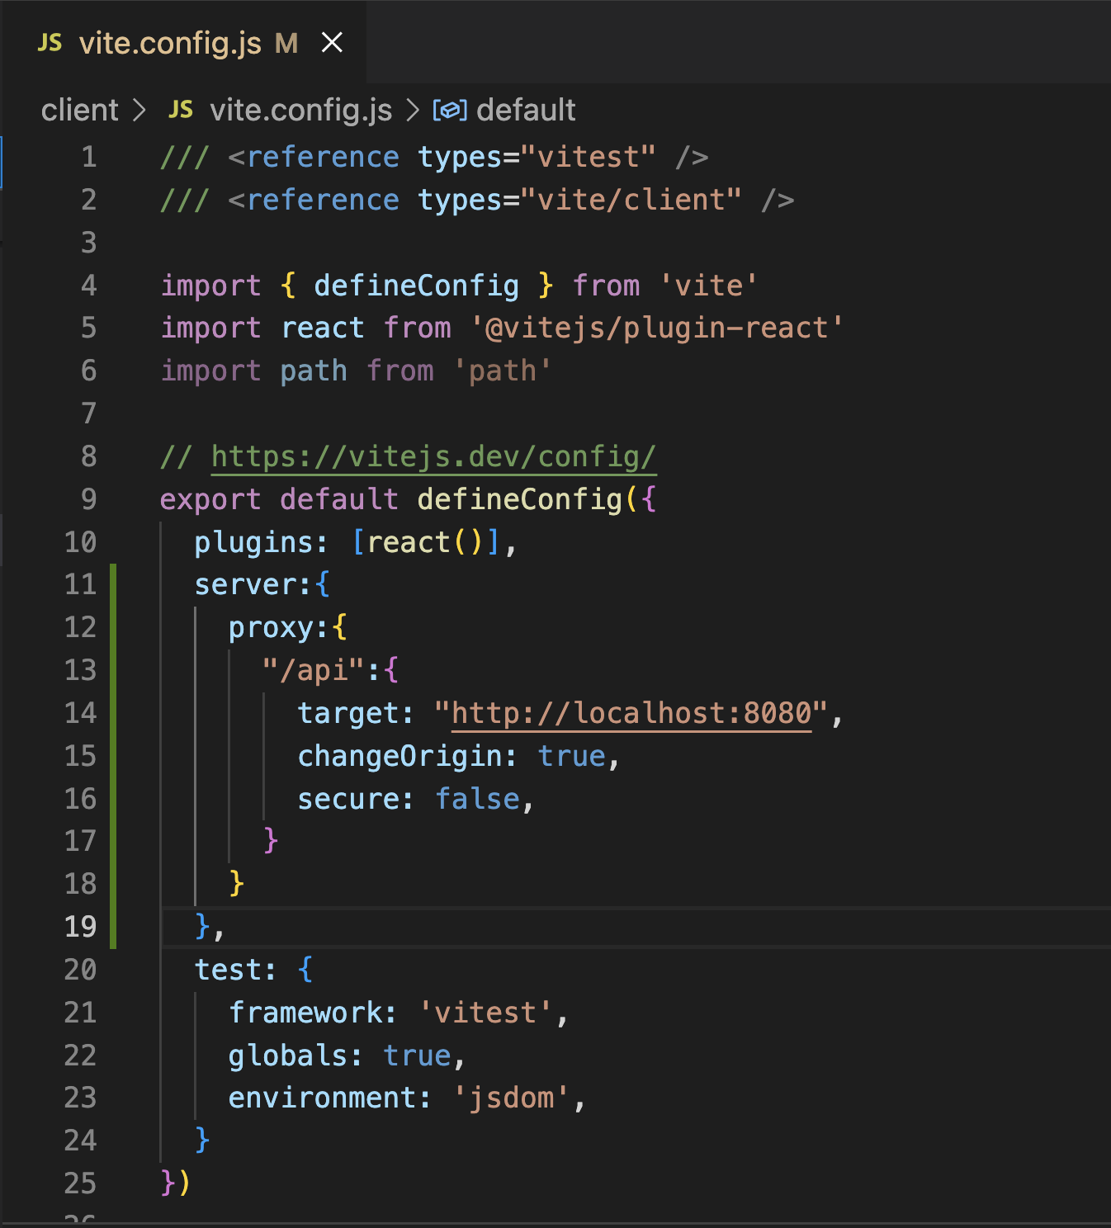

- This proxy will tell the server what port to use, so you NOW can safely delete all references to your localhost in your CLIENT React files. IMPORTANT: Delete only the part that says “http://localhost:8080”
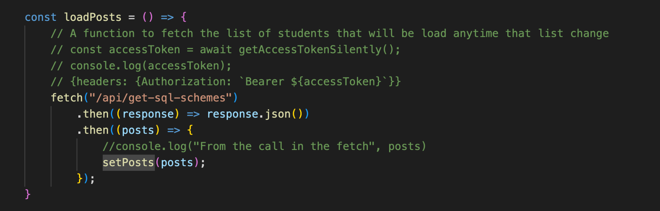

- Once you update all your fetch calls to localhost you can successfully create your build production package. Go to your terminal to the CLIENT folder and run the command npm run build. You will see a message like this: (this could take a while!)
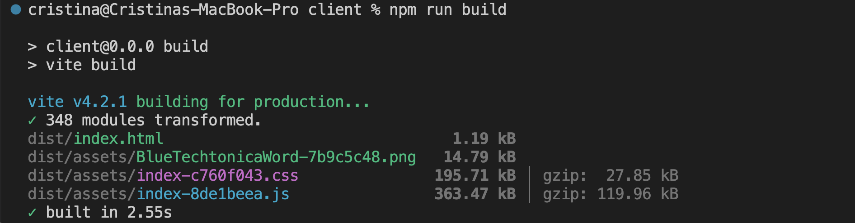

- Once that process is finished, if you do ls in your client folder, you will see a build folder called “dist”. That folder contains your production code.
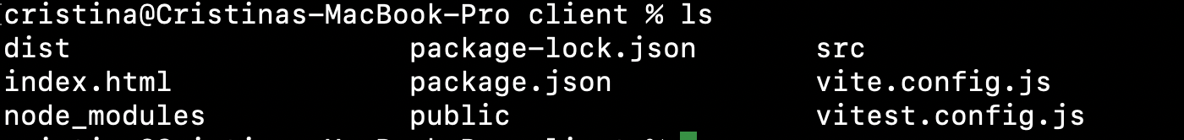

- Make sure that you include that build folder in your .gitignore. You don’t want your production code on Github
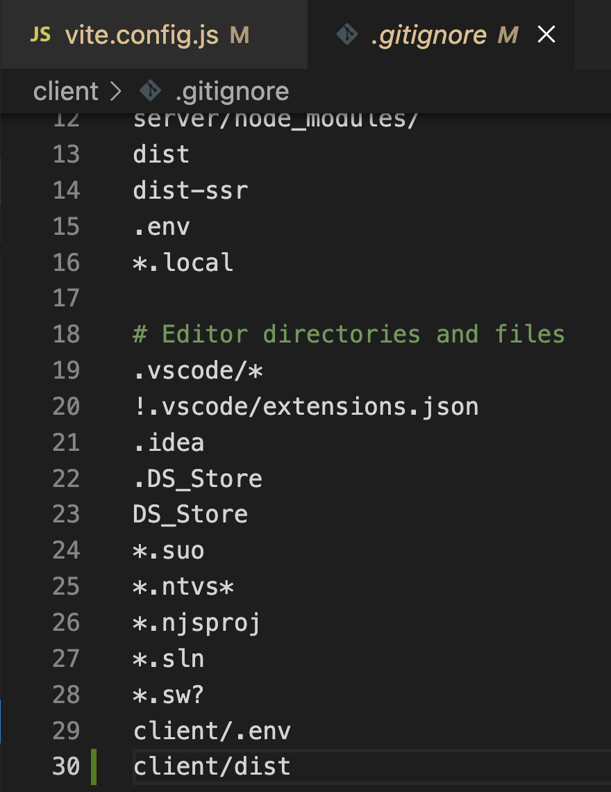

Things to modify in your SERVER folder

Several things need to change in your server.js file in order to tell your server that now you have a production code separate it from your dev environment

- Include Path at the top of your file:

- Create the route for the Build directory using path and tell the express app that you’re using that path

- Add the process.env.PORT option to your port variable

- Change the endpoint “/” to render index.html as the start point of your application (this index.html will come from your build folder “dist” from VITE)
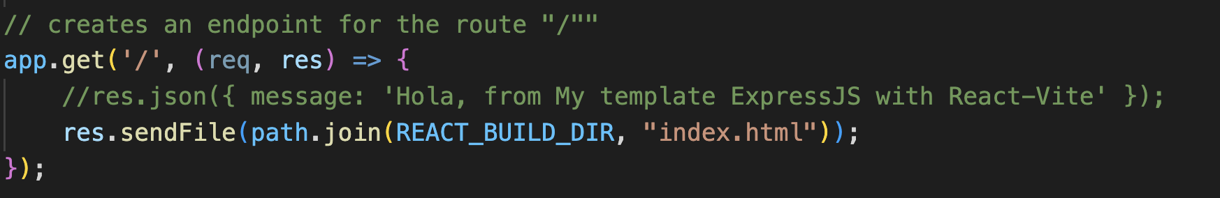

How to test these changes?

At this point, if you go to your server folder and run npm start, you will see your whole application running in your localhost. This will be your production server and code! (This is the localhost on your server.js file).

Review: Thinking Back
Ask yourself. Which were topics that you were foggy on? In your core skills mock interviews, were there subjects that you weren’t able to articulate well? Use your feedback and list of topics to review! Can you answer the following today without researching the answer:

- What do the functions map, filter, and reduce do, when would be a good example of when to use them? Does this mutate my data?
- What are the two ways to add style to a component in React? (think of instead class=, you use…
- How do SEO and accessibility work together?
- What is inheritance?
- What is runtime complexity? Can you give me examples of the 3 major runtimes we have covered?
- What is Node? What is it used for?
- What is Express.js? What is it used for?
- What is the difference between an OS and application software (like Chrome, word, solitaire ,etc.)?

